Ezkylle Opiniano 11/18/2025
NW – 301 6BLOCKTECH

HelloWorld.sol
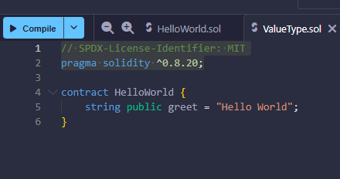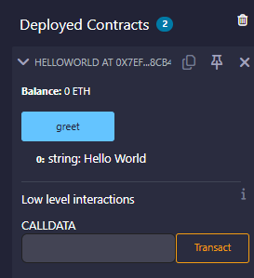
HelloWorld smart contract written and deployed using the Remix IDE. The contract contains one public string variable, greet, which is set to "Hello World". Because it is public, Solidity automatically creates a function that lets anyone read its value.
After deploying the contract in Remix, a button named greet appears in the "Deployed Contracts" panel. Clicking this button calls the getter function and displays the stored message. The output confirms that the contract successfully returns "Hello World".

ValueType.sol
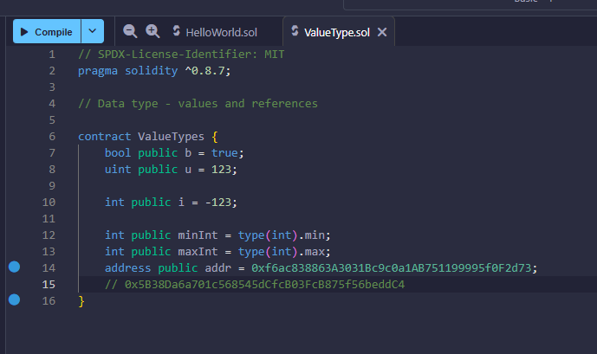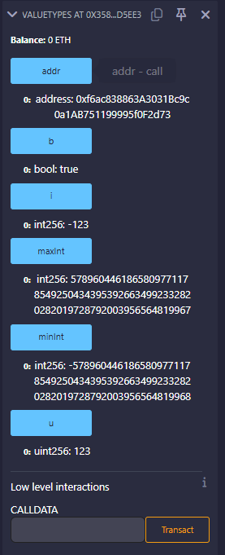
This contract demonstrates several basic Solidity value types. It defines a boolean (b), an unsigned integer (u), and a signed integer (i). It also shows how to access the minimum and maximum values of an integer type using type(int).min and type(int).max. Additionally, the contract includes an address variable, initialized with a sample Ethereum address.
After deploying the contract in Remix, each variable appears as a readable button in the “Deployed Contracts” panel. Clicking any of these buttons returns the stored value for that variable such as true for the boolean, numeric values for the integers, and the stored Ethereum address for the address type. This provides a clear, interactive demonstration of how Solidity stores and exposes different value types through public variables.

Funtion.sol
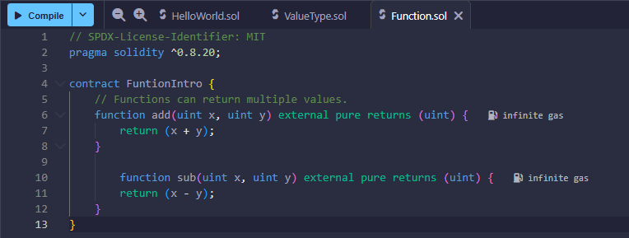
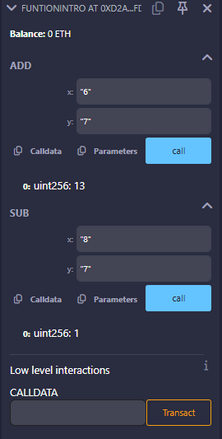
This contract demonstrates how to create and use basic functions in Solidity. It defines two external, pure functions: add and sub. Each function takes two unsigned integers as inputs. The add function returns the sum of the two values, while the sub function returns their difference. Because the functions are marked as pure, they do not read or modify any state they simply perform calculations based on the inputs provided.
After deploying the contract in Remix, the interface displays input fields for both functions. By entering numbers and clicking Call, Remix passes those values to the contract and displays the result. For example, entering 6 and 7 in the add function returns 13, while entering 8 and 7 in the sub function returns 1. This setup provides a straightforward demonstration of how functions accept parameters and return computed values in Solidity.

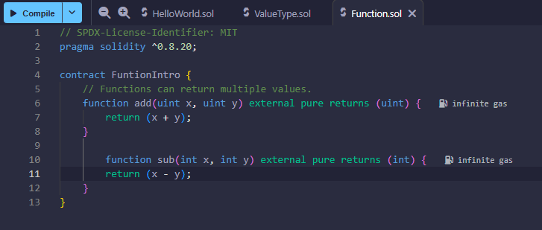
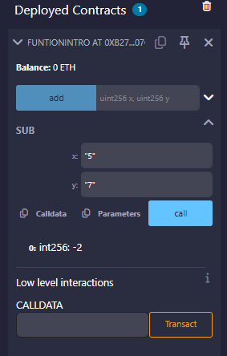
Changed sub to int instead of uint for so that we can have a negative integer and the y value is higher than the x value

LocalVariables.sol
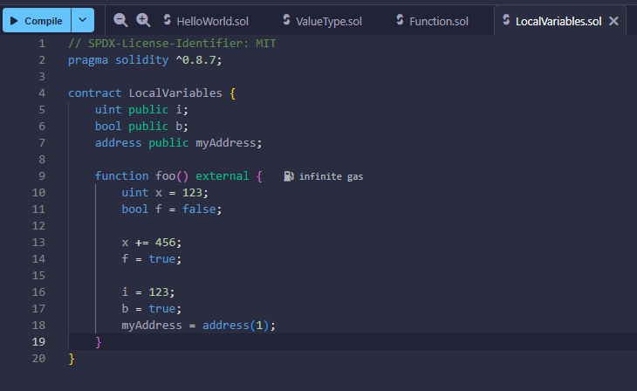
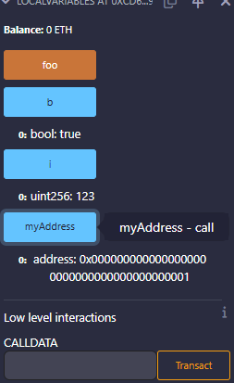
A Solidity contract named LocalVariables deployed in Remix, with a function foo() that initializes local variables. Inside the function, local variables such as uint x = 123, bool f = false, and address myAddress are defined but are not stored on the blockchain. These local variables are used within the function scope and don't affect the contract's state variables. The contract also includes state variables like a, b, and myAddress, which can be interacted with via the Remix interface. For example, users can set b = true, i = 123, and myAddress to a specific Ethereum address before executing the function. However, the local variables only exist temporarily during the function execution and do not modify the contract’s stored data.
GlobalVariables.sol
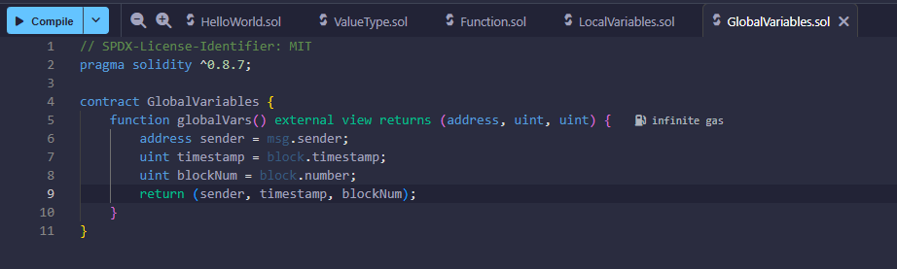
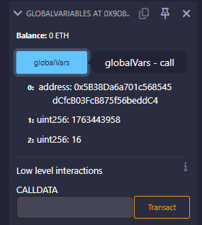
A Solidity contract named GlobalVariables, which includes a function globalVars() that returns three global variables: the sender's address (msg.sender), the current block's timestamp (block.timestamp), and the block number (block.number). These global variables are accessible by any contract, providing information about the transaction and the block in which it is executed. When the globalVars function is called through the Remix interface, it returns the sender's address, the current timestamp, and block number. In the example, the values returned are an address (0x5B83...), a timestamp (1763443958), and a block number (16). This demonstrates how global variables in Solidity can be used to fetch real-time data from the blockchain.

Review Questions
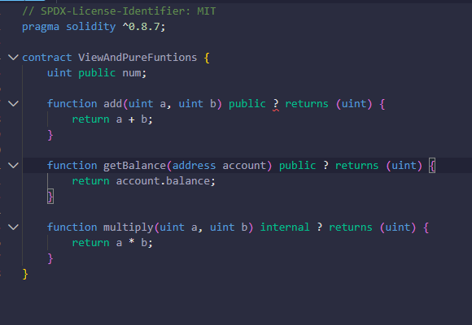
Answers:
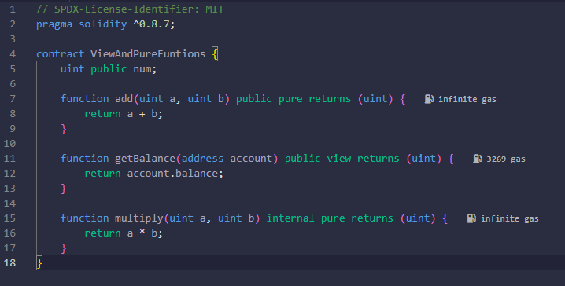
- Pure – It is a self-contained function that only performs a computation based on its inputs and does not rely on or modify the contract's state.
- View – Since this function reads a value (the account's balance) from the blockchain but does not modify the blockchain state, it should be marked as view. The view modifier allows the function to read from the contract's state without any side effects.
- Pure – The function purely performs a mathematical operation with its input parameters and does not depend on or modify any state variables, so it is also marked as pure.
pure: The function does not read or modify any state data. It is entirely self-contained and depends only on the inputs passed to it.
view: The function reads state data but does not modify it. It can access state variables or other blockchain data but cannot alter anything.

